Problem set

{it is to be made clear that this is just the problems and solutions to the set of problems that will be in the game. }

Problem set 1

The electricity has gone out in a building. Three generators must be powered up in a certain fashion to restore power. After each generator is turned on, a power switch must be flicked to divert power.

in a room there are a tile arranged in order 6x6 as shown below

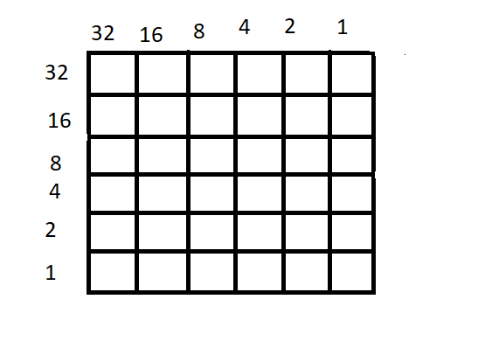

the room is divided into the tiles shown above. the tiles will light up a certain color. And according to the tile set that has lit up the player must find which room out of 20 the backup generator exists. After the generator is turned on. the player must go to the switch which will take a four-digit input to recognize which generator to divert power from.

Sample tile lighting

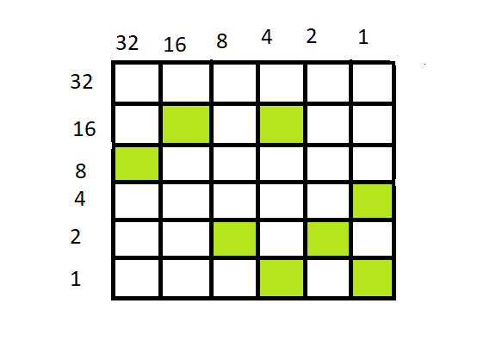



Solution:

The tile set readings are first taken horizontally

Adding the tile value in the columns(horizontal)

1st (0) + 2nd(16+4) + 3rd(32) + 4th(1) + 5th(8+2) + 6th(4+1)=68

Adding the values in the rows(vertical)

1st (8) + 2nd(16) + 3rd(2) + 4th(1+16) + 5th(2) + 6th(1+4)=50

Now you have two numbers with you 65 and 50

There are 20 rooms with a generator each. The generator is in room 18 as 68-50 is 18.

The code which identifies the 15th generator is 6850. Hence the problem to power up all three generators will be solved.

Constraints of the problem.

Let the sum of all the columns of the tile set is a

Let the sum of all the rows of the tile set be b

a-b<20

a ,b<100

Problem set 1.2

If the problem is too hard it will be simplified. The problem is modified to combat the time it might take for some of more beginner level players. As the same, the player will be taken into a 6x6 room, with randomly lit up areas. The horizontal and vertical areas will have different values as usual. Instead of having the player to add up the numbers without prompt, each end will have a monitor where they are expected to enter the number. After the number has been entered, they will be asked to enter the numbers in the rest off the monitors. After all the monitors on one side have had their respective numbers entered, a cord will emerge from the monitor. The player is to connect these into the monolith (hexagonal shaped object). After all the cords have been connected. The hexagon will show a value which is equal to the sum of all the numbers from the monitor. Once the two hexagons have been connected to the monitors and the numbers displayed, the rest of the problem functions as the above. the numbers on subtracting will give the room number which the generator is present, and the code to divert power to the generator will be a combination of the two numbers.

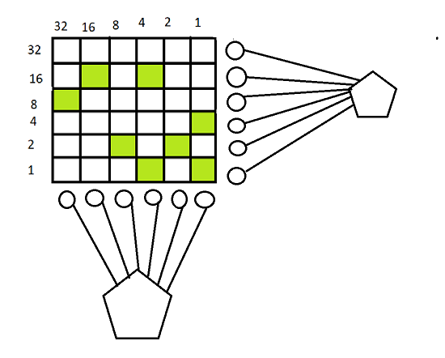

Problem set 1.3

Each row/column can correspond to an operation that need to show an output into a machine.

STEP BY STEP PROCEDURE.

1st

If the player checks the machine the player will see that that they have to input the number that is represented by the lighted green tiles.

2nd

When the player interacts with the monitor, a number shows up. The player must light up the relevant tiles to get the number representation.

3rd

When the player interacts with the third monitor, they are told that they can interact with the rightmost 3 tiles and the other tiles cannot be changed. A number flashes on the monitor and the player is told that they are given 3 tries to create the number on the monitor. The only way that they can do this is by pressing a left or right arrow. Each time the player presses the arrow, one chance is used. If the player presses left the whole tile set values moves towards the left. The left most value does not get transferred to the rightmost tile but is deleted. Same applies to the right shift.

4th

Operations on the second and third row will give you the fourth row.

If one tile is lit up in any of the cell in the same column on the 2nd and 3rd row, the cell in the same column should be lit up, else it should stay dark. The layer must light the tiles accordingly

5th

When the player activates the 5th monitor, the whole shifts and the player is told that the roles have reversed. The player must enter the number shown on the screen except the lit tiles are to be ignored and the non-lit tiles are added.

6th

The player essentially must XOR the 1st and 2nd row, the answer must be XORed with the 3rd row and so on, until all the 5 rows are XORed. The final answer will give the 6th row.

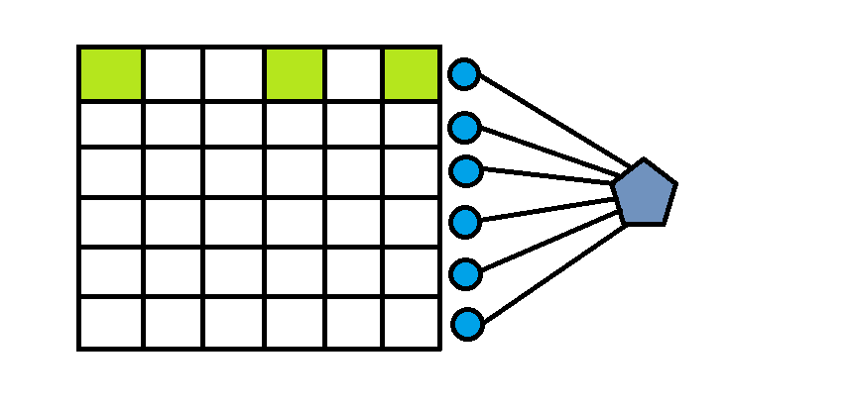

The monolith attachment and the switch and generator part will work as usual.

The rest of the monitors on the bottom side will pop up and when the wires are attached to the monolith, the number will be obtained.

